Monaghan Local Sports Partnership
Ballybay Town Council Offices, Main St., Ballybay, Co. Monaghan Ph: 042/9755126
www.monaghansports.ie

Active Leadership Training Workshop

Booking Form 2013
February Fri 24th May 2013 6.30 – 9.30 pm & Sat 25th May 9.00 am – 5 pm
Date of course you wish to attend
Castleblayney Enterprise Centre
Venue of course you wish to attend

- Return completed application form along with appropriate fee (€25) to the address below
(€35 for participants of clubs outside County Monaghan).
All cheques must be made payable to Monaghan County Council.
- As demand for places is high, please make every effort to give sufficient notice of cancellation and allow others to make use of the limited places available

Please note that there are no refunds for cancellations received within 24 hours prior to the course.

Please complete details clearly in print or block capital
Name _______________________________________________________________
Address

Club / Organisation
Contact numbers (Home) (Mobile)
E-mail Address*
Signature:
Date:

* Please complete e-mail details if you wish to be contacted about future courses / seminars etc.

……………….…………………………………For Monaghan Sports Partnership Office Use Only……………………………………….…………

Payment Received € ______ Date:______________ Signed:______________________

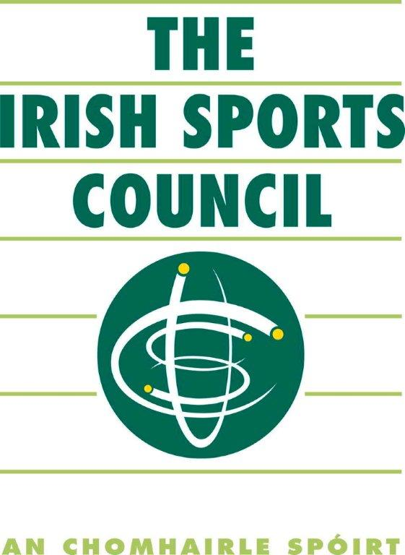
Active Leadership training is an Irish Sports Council National Programme

